**Assignment on Collection Framwork**

**Q1.Why collection framework in java**

**Ans:**

**The Java Collections Framework provides a comprehensive set of classes and interfaces to handle and manipulate groups of objects. It offers several benefits:**

**1. *Reusable Data Structures:* The framework includes commonly used data structures like lists, sets, maps, queues, etc. These structures are implemented in a generic and reusable way, saving developers from reinventing the wheel for each project.**

**2. *Consistency:* The framework establishes a uniform and consistent interface for various data structures. This consistency makes it easier for developers to learn and use different collections.**

**3. *Interoperability:* Collections can work seamlessly with each other, allowing developers to switch between different data structures without major code changes. For example, you can easily change from using an ArrayList to a LinkedList without modifying the rest of your code.**

**4. *Algorithms:* The framework provides standard algorithms (sorting, searching, etc.) that work on any collection, promoting code reuse and reducing the need for developers to implement these algorithms from scratch.**

**5. *Performance:* The implementations in the Collections Framework are well-optimized, providing efficient data manipulation operations.**

**6. *Thread-Safety:* It includes synchronized versions of collections, making it easier to create thread-safe applications when needed.**

**In essence, the Java Collections Framework simplifies the process of working with collections of objects, offering a standardized way to handle, store, and process data in Java applications**

**Q2What is Collection interface?**

**Ans:**

**The `Collection` interface in Java is the root interface of the Java Collections Framework. It extends the `Iterable` interface and represents a group of objects, known as elements. It defines the fundamental methods that all collections will have.**

**Here are some of the key methods declared in the `Collection` interface:**

**1. `int size()`: Returns the number of elements in the collection.**

**2. `boolean isEmpty()`: Returns `true` if the collection contains no elements.**

**3. `boolean contains(Object element)`: Returns `true` if the collection contains the specified element.**

**4. `Iterator<E> iterator()`: Returns an iterator over the elements in the collection.**

**5. `boolean add(E element)`: Adds the specified element to the collection.**

**6. `boolean remove(Object element)`: Removes the specified element from the collection.**

**7. `boolean containsAll(Collection<?> c)`: Returns `true` if the collection contains all the elements in the specified collection.**

**8. `boolean addAll(Collection<? extends E> c)`: Adds all the elements from the specified collection to the collection.**

**9. `boolean removeAll(Collection<?> c)`: Removes all the elements in the specified collection from the collection.**

**10. `void clear()`: Removes all elements from the collection.**

**The `Collection` interface is the foundation for more specific interfaces like `List`, `Set`, and `Queue`, each tailored to different types of collections. Classes that implement the `Collection` interface provide concrete implementations of these methods based on the specific characteristics of the collection they represent.**

**Q3What is default package in java.**

**Ans:** In Java, if you do not explicitly specify a package for your class, it belongs to the default package. Classes in the default package can be accessed from other classes within the same package, but they cannot be accessed from classes in named packages. It's generally recommended to avoid using the default package and instead organize your classes into named packages to promote better code organization and maintainability.

**Q4List the types of datatypes with size and give an example of each by doing declaring and initializating the variables.**

**Ans:** There are two types of datatypes 1Primitive 2Non-primitive

In primitive there are 8 datatypes :-

datatypes size Default size

|  |  |  |
| --- | --- | --- |
| 1byte | 1 byte | 0 |
| 2 short | 2 byte | 0 |
| 3int | 4 byte | 0 |
| 4long | 8 byte | 0 |
| 5float | 4 byte | 0 |
| 6double | 8 byte | 0 |
| 7boolean | 1 bit | False |
| 8char | 2 byte | empty |

byte b=10;

short s=15;

int I = 100;

long = 124578963654l;

float f=55f;

double d = 271828;

boolean p = true;

char c= ‘A’;

**Non primitive datatypes**

**String:** A sequence of characters used to represent text String is a class in Java, not a primitive data type

String myString = "Hello, World!";

**Array:** A container object that holds a fixed number of values of a single type

int[] myIntArray = {1, 2, 3, 4, 5};

**Class Objects:** Objects created from user-defined classes

public class MyClass {

// class definition

}

MyClass myObject = new MyClass();

**Interfaces:** Similar to classes but they only contain method signatures and fields

public interface MyInterface {

// interface definition

}

**Q5Write a program to display the names of your friends by calling the static methods.**

**Ans:** 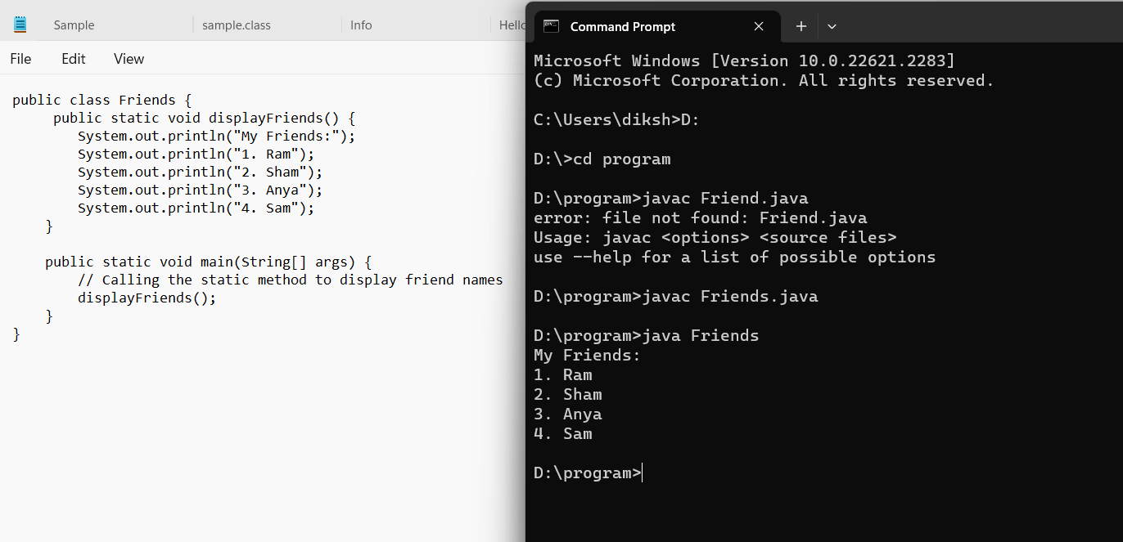

**Q6Write a program to add two number by using static method**

**Ans:** 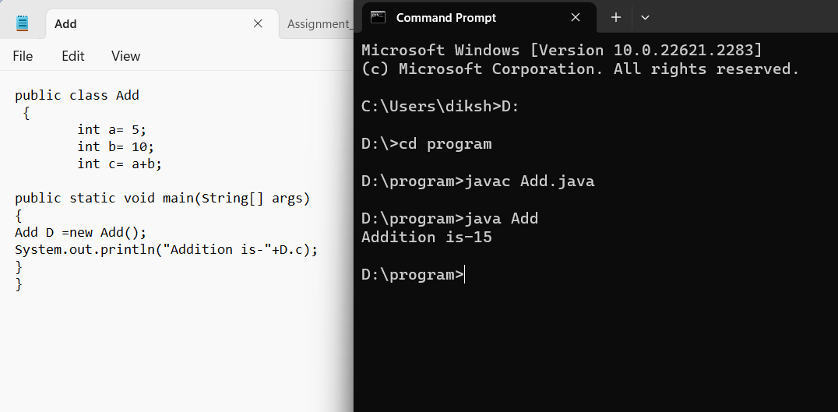

**Q7What are the rules of naming the java file.**

**Ans:**

1. *File Name Must Match the Class Name*: The name of the Java file must exactly match the name of the public class it contains. For example, if your class is named `MyClass`, the file must be named `MyClass.java`.

2. *Use CamelCase*: Class names should be in CamelCase. CamelCase means the first letter of each word is capitalized (except the first word). For example, `MyClass`, `CalculatorService`, etc.

3. *Use .java Extension*: Java source files must have a `.java` extension. For example, `MyClass.java`.

4. *Use Letters and Digits*: File names should only contain letters (uppercase or lowercase) and digits. They should not contain spaces or special characters.

5. *Start with a Letter*: The file name must start with a letter (uppercase or lowercase). It should not start with a digit.

6. *Avoid Java Keywords*: Do not use Java keywords as file names. For example, `int.java` is not a valid file name because `int` is a keyword in Java.

Following these rules ensures that your Java files are named correctly and can be compiled without any issues. It also helps maintain a consistent and readable codebase.

**Q8what are the rules of naming the class**

**Ans:** 1. *Use CamelCase*: Class names should be in CamelCase, where the first letter of each word is capitalized. For example, `MyClass`, `CalculatorService`, `StudentRecord`, etc.

2. *Start with a Capital Letter*: Class names always start with a capital letter. This helps distinguish class names from variable names and method names, which typically start with a lowercase letter.

3. *Avoid Underscores*: Do not use underscores (_) to separate words in class names. Use CamelCase instead. For example, prefer `StudentRecord` over `Student_Record`.

4. *Be Descriptive*: Choose meaningful and descriptive names for your classes. The name should indicate the purpose of the class. For example, if your class represents a car, a suitable name might be `Car` or `Vehicle`.

5. *Noun or Noun Phrase*: Class names should be nouns or noun phrases, representing objects or concepts in your application. For example, `Person`, `Customer`, `FileReader`, etc.

6. *Avoid Abbreviations*: Try to avoid abbreviations in class names unless the abbreviation is well-known and widely used (e.g., `URL`, `HTML`, etc.). Using descriptive names improves the readability of your code.

7. *Use Singular Form*: Class names should be in singular form rather than plural. For example, use `Car` instead of `Cars`, `Book` instead of `Books`.

**Q9what are the rules for naming the methods**

**Ans:** 1. *Use CamelCase*: Method names should be in camelCase, where the first letter of the name is lowercase and the first letter of each subsequent concatenated word is capitalized. For example, `calculateTotalAmount()`, `getUserInfo()`, `printInvoice()`, etc.

2. *Be Descriptive*: Choose meaningful and descriptive names for your methods. A method name should clearly indicate what the method does. Avoid single-character or vague names. For example, use `calculateArea()` instead of `calc()`, and `getUserDetails()` instead of `getInfo()`.

3. *Use Verbs*: Method names should typically start with a verb that describes the action performed by the method. For example, `calculateTotal()`, `validateUser()`, `printReport()`, etc.

4. *Avoid Abbreviations*: Similar to class names, try to avoid abbreviations in method names unless the abbreviation is well-known and widely used. Using descriptive names improves the readability of your code. For example, use `initializeDatabase()` instead of `initDB()`.

5. *Follow Java Naming Conventions*: Adhere to the Java naming conventions. For example, accessor methods (methods used to retrieve the value of an instance variable) should start with "get" or "is" for boolean properties (e.g., `getName()`, `isComplete()`).

6. *Use Parameters*: If a method requires parameters, use descriptive names for the parameters. Parameter names should also follow camelCase. For example, `calculateArea(int length, int width)`. Descriptive parameter names make it clear what values are expected.

7. *Avoid Overloading*: Avoid creating methods with the same name but different parameter lists (method overloading) unless they serve a similar purpose. Overuse of method overloading can lead to confusion.

8. *Consistency*: Be consistent with the naming style throughout your codebase. If you follow a specific naming convention for methods, stick to it to maintain consistency.

**Q10what are the rules for naming variables in java**

**Ans:**

1. *Use CamelCase*: Variable names should be in camelCase, where the first letter of the name is lowercase and the first letter of each subsequent concatenated word is capitalized. For example, `firstName`, `totalAmount`, `numberOfStudents`, etc.

2. *Be Descriptive*: Choose meaningful and descriptive names for your variables. A variable name should clearly indicate the purpose of the variable. Avoid single-character or vague names. For example, use `customerName` instead of `cName`, and `totalSales` instead of `total`.

3. *Use Letters and Digits*: Variable names can consist of letters (uppercase or lowercase) and digits. They should not start with a digit.

4. *Avoid Special Characters*: Do not use special characters such as @, $, and % in variable names.

5. *Avoid Java Keywords*: Do not use Java keywords (reserved words) as variable names. For example, `int`, `class`, `while` are keywords and cannot be used as variable names.

6. *Use Meaningful Names*: Choose variable names that reflect the content or use of the variable. For example, use `userInput` instead of `data` if the variable stores user input.

7. *Constants*: If a variable is a constant (its value never changes), use all uppercase letters with underscores separating words. For example, `MAX_VALUE`, `PI`, `DEFAULT_SIZE`.

8. *Class Member Variables*: Class member variables (instance variables) should start with "this" to distinguish them from method parameters. For example, `this.age` refers to the member variable `age` of the class.

9. *Local Variables*: Local variables (variables declared inside methods) should be named in camelCase and be descriptive. For example, `int numberOfItems`.

10. *Final Variables*: If a variable is declared final (its value cannot be changed), it should be in all uppercase letters with underscores separating words.

**Q11which is the main entry point of java program**

**Ans:** In Java, the main method is the entry point of a Java program. When you run a Java program, the Java Virtual Machine (JVM) is responsible for executing the program. The JVM looks for the `public static void main(String[] args)` method in the class that you specify as the starting point of your program. The `main` method must be defined as `public` so that the JVM can access it.

So, to answer your question, the JVM is responsible for invoking the `main` method of a Java program when you run the program.

**Q12who is invoking the main method of java**

**Ans:** In Java, the main method is the entry point of a Java program. When you run a Java program, the Java Virtual Machine (JVM) is responsible for executing the program. The JVM looks for the `public static void main(String[] args)` method in the class that you specify as the starting point of your program. The `main` method must be defined as `public` so that the JVM can access it.

**Q13why main has to be static method**

**Ans:** 1. *Entry Point:* The `main` method serves as the entry point of a Java application. When you run a Java program, you don't create an object of the class containing the `main` method. Instead, the JVM directly calls the `main` method to start the program.

2. *Static Context:* The `main` method is static so that it can be called by the JVM before any objects are created for the class. In a static method, you cannot access instance-specific variables and methods directly because there is no instance associated with it. By declaring `main` as `static`, you indicate that it belongs to the class and not to any specific instance of the class.

3. *Simplicity:* Making `main` static simplifies the process of starting a Java program. You don't have to worry about creating an object of the class first. It can be called by the JVM directly from the class itself.

**Q14components of java program are?**

**Ans: 1. *Package Declaration (Optional):\*** You can organize your classes into packages. The package declaration, if used, appears at the beginning of the file.

**2. *Import Statements (Optional):\*** If your program uses classes from other packages, you need to import them. Import statements, if used, come after the package declaration and before the class declaration.

**3. *Class Declaration:\*** Every Java program consists of at least one class. The class declaration is where you define the properties and behaviors of objects. It contains methods and variables.

**4. *Main Method:\*** The `main` method is the entry point of a Java program. It is mandatory in every Java application. The program execution starts from the `main` method.

**5. *Variables:\*** Variables are used to store data values. They must be declared before they are used.

**6. *Methods:\*** Methods define the behavior of objects. They contain a set of instructions that perform a specific task.

**7. *Comments:\*** Comments are used to describe the code and improve its readability. There are single-line comments (`//`) and multi-line comments (`/* */`).

**Q15In which area .class is stored?**

**Ans:** In a Java Virtual Machine (JVM), the class-related information is stored in the *Method Area, which is also known as the **Class Area*. The Method Area is a part of the JVM's memory where the JVM stores class structures, metadata, method data, static variables, constant pool, and other class-related data.

When a Java program is executed, the JVM loads class files and stores information about classes and interfaces in the Method Area. This includes details such as method signatures, field names, method code, method and field references, and other metadata required by the program.

It's important to note that in Java 7 and earlier versions, the Method Area was part of the Permanent Generation (PermGen) space. However, starting from Java 8, PermGen was replaced by Metaspace, which also includes the memory allocated for class-related information. Metaspace can dynamically adjust its size, making it more flexible compared to the fixed-size PermGen space.

**Q16In which area object are stored?**

**Ans:** In a Java Virtual Machine (JVM), objects are stored in the *Heap Memory* area. The heap is a runtime data area in which objects are dynamically allocated memory space. It's the area where all objects (instances of classes) and arrays are allocated at runtime.

When you create a new object in Java using the `new` keyword, the JVM allocates memory for that object on the heap. Objects stored in the heap can be accessed by multiple threads, making it a suitable storage area for objects in Java applications.

The heap memory is managed by the Java garbage collector, which is responsible for identifying and reclaiming memory occupied by objects that are no longer reachable or in use. This automatic memory management ensures efficient use of memory and helps prevent memory leaks in Java programs.

**Q17Why do we call as java simple?**

**Ans:** Java is often considered a simple programming language due to several design choices and features that make it relatively easy to learn and use, especially for beginners. Here are some reasons why Java is often referred to as simple:

1. *Simple Syntax:* Java has a clean and straightforward syntax that resembles C++, making it easier for programmers to read, write, and maintain code. It avoids complex features found in other languages, which simplifies the learning curve.

2. *Object-Oriented:* Java is purely object-oriented, which means it revolves around objects and classes. This simplifies the organization of code into reusable components and encourages good programming practices.

3. *Platform Independence:* Java code is compiled into platform-independent bytecode, which can run on any Java Virtual Machine (JVM). This portability simplifies the development of cross-platform applications.

4. *Automatic Memory Management:* Java handles memory management automatically through its garbage collection mechanism. Programmers don't have to worry about manual memory deallocation, reducing the chances of memory-related errors.

5. *Standard Libraries:* Java provides a vast set of standard libraries and APIs (Application Programming Interfaces) that simplify complex tasks. These libraries cover everything from data structures to network communication, saving developers time and effort.

6. *Strongly Typed Language:* Java is a strongly typed language, which means variables must be declared with a specific data type. This helps catch type-related errors at compile-time, enhancing program reliability.

7. *Rich Documentation:* Java comes with extensive documentation and community support. Java's official documentation and numerous online resources simplify the process of finding solutions to common programming problems.

8. *No Explicit Pointers:* Java doesn't use explicit pointers, reducing the risk of pointer-related errors such as null pointer exceptions, which can be common in languages like C and C++.

9. *Security Features:* Java includes built-in security features like classloaders and bytecode verification, enhancing the overall security of Java applications.

**Q18Write a program to sub, division and multiplication by**

**using static method,pass the arguments and return the result**

**to main method and print the result.**

**Ans:** 